By Ballo-02

GPS Simulation

Owen B

Tested on Aston Martin rig

Contents

Introduction 2

Requirements 2

Software 2

Hardware 2

Installation for Windows 2

Installing Gps-sdr-sim 2

Installing SatGen 3 2

Installing HackRf One Drivers 2

Getting the brdc file for satellite positions 2

Installation for Linux 2

Installing Gps-sdr-sim 2

SatGen 3 3

Hardware Installation 4

Install the TXCO in the following location. 4

Installing Attenuator 4

Create your own location 5

Getting the brdc file for satellite positions 5

Create static location 5

Create moving target 5

Perform GPS simulation using an Aston Martin Rig 5

# Introduction

This document contains information on how to spoof GPS location both static and moving using a modified HackRF One. This can be done on most OS systems but this document will be only reporting for Linux and Windows.

# Requirements

## Software

* Gps-sdr-sim
* SatGen 3 (For drawing own route/speed)
* Satellite position file (download daily) – brdc file

## Hardware

* HackRF One
* 30db Attenuator
* A TXCO module (more details mentioned further down)

# Installation for Windows

## Installing Gps-sdr-sim

1. Download Gps-sdr-sim from <https://github.com/osqzss/gps-sdr-sim>
2. Unzip the contents
3. Start Visual Studio.
4. Create an empty project for a console application.
5. On the Solution Explorer at right, add "gpssim.c" and "getopt.c" to the Souce Files folder.
6. Select "Release" in Solution Configurations drop-down list.
7. Build the solution.

## Installing SatGen 3

1. Install SatGen 3 from - ‘https://www.labsat.co.uk/index.php/en/customer-area/software-firmware’

## Installing HackRf One Drivers

1. Install PothosSDR from - https://downloads.myriadrf.org/builds/PothosSDR/

## Getting the brdc file for satellite positions

1. Create an account on ‘https://cddis.nasa.gov’
2. Download the latest brdc from ‘https://cddis.nasa.gov/archive/gnss/data/daily/’ -examples from ‘https://cddis.nasa.gov/archive/gnss/data/daily/2023/brdc/’ ‘brdc0320.23n.gz’
3. Extract the file

# Installation for Linux

## Installing Gps-sdr-sim

1. Install prerequisites –
2. sudo apt install gnuradio libhackrf0 hackrf libhackrf-dev
3. sudo make
4. sudo make install

# SatGen 3

1. Click Draw Route
2. Graphical user interface, map

   Description automatically generatedSelect pins on where you want the route to go
3. Click User defined
4. Click save file
5. Graphical user interface, chart

   Description automatically generatedMake sure the file is saved as .txt and looks something similar below with the values in. You can also adjust speed by pressing the speed button and changing the value

# Hardware Installation

## Install the TXCO in the following location.

-More Information Files- https://github.com/osqzss/gps-sdr-sim/tree/master/extclk

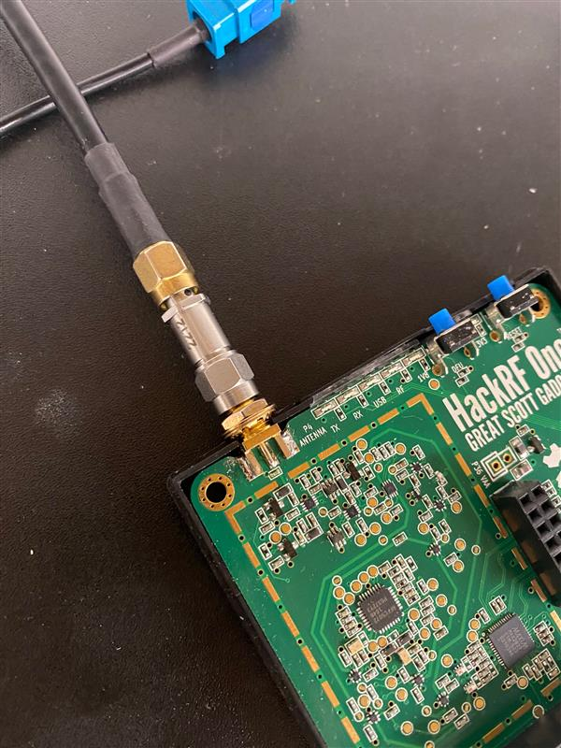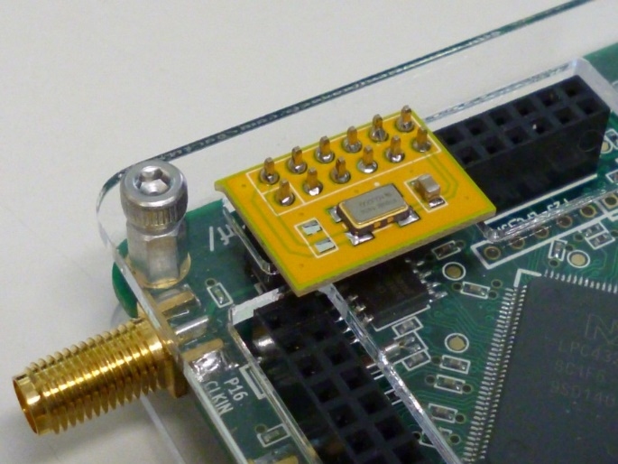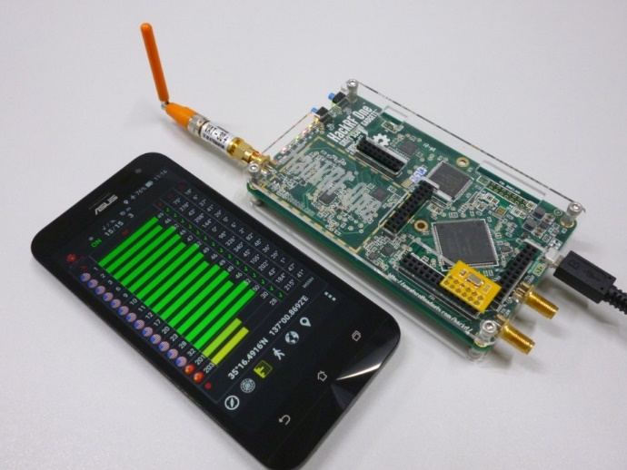-Note- Only solder one capacitor on or else won’t work

## Installing Attenuator

30db connected via male SMA HackRF and female output to cable connected to either antenna or hardwired to rig

# Create your own location

## Getting the brdc file for satellite positions

Note- Old brdc files can be used but please be aware of the date and time changing/inccorect

1. Create an account on ‘https://cddis.nasa.gov’
2. Download the latest brdc from ‘https://cddis.nasa.gov/archive/gnss/data/daily/’ -examples from ‘https://cddis.nasa.gov/archive/gnss/data/daily/2023/brdc/’ ‘brdc0320.23n.gz’
3. Extract the file

## Create static location

Longitude - 40.812800

Latitude - -60.005900

1. Sudo ./gps-sdr-sim -b 8 -e YOUR_BRDC_FILE_HERE -l 40.812800,-60.005900,100

## Create moving target

Triumphv3 – set route for the GPS to follow

1. Go to SatGen 3
2. Sudo gps-sdr-sim -b 8 -e brdc3540.14n -g triumphv3.txt

# Perform GPS simulation using an Aston Martin Rig

Notes for windows users:

* Don’t need sudo
* Whatever the project name was when compiled use that instead of ‘gps-sdr-sim’

Create static/moving location (See above)

1. 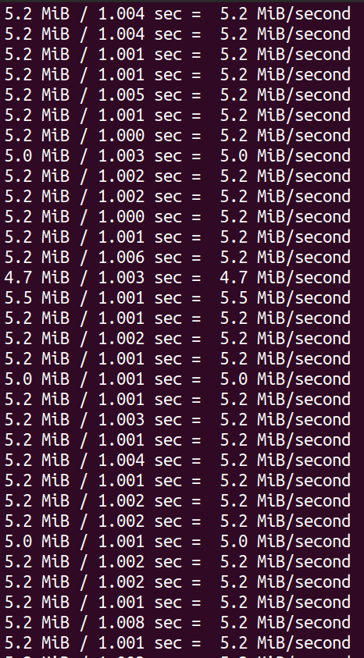sudo hackrf_transfer -t gpssim.bin -f 1575420000 -s 2600000 -a 1 -x 0
2. 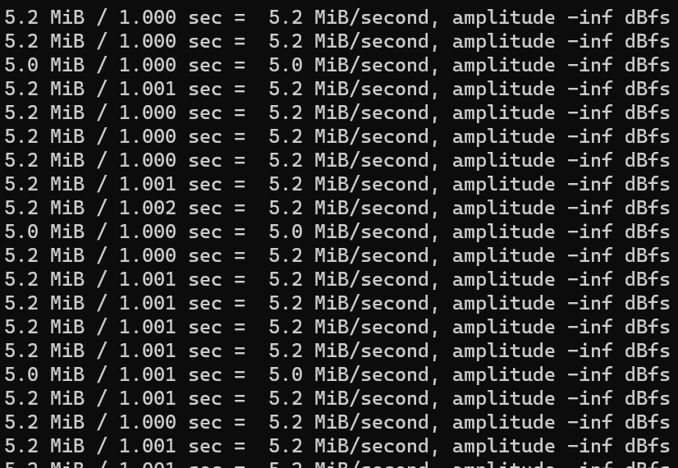Windows gives a slightly different result.